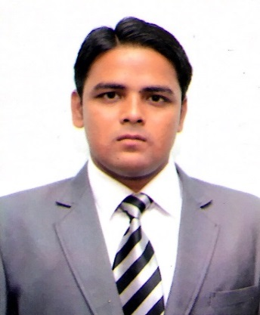
Prince Kumar

Petroleum engineering graduate
University of Technology and
Management – Shillong

Personal No. +91 8789679892
E-mail ID : rudraprince99@gmail.com
LinkedIn ID : http://linkedin.com/in/prince-kumar-61647b8a

Objective

Work, learn & lead in oil and gas sector that can help me mature professionally with my specialization and contribute it all to the organization I work.

Ready to relocate to any place, condition, Environment, ready to work at odd shifts and spend at camps, ready to stay away from family.

ACAMEDIC CREDENTIALS

Qualification | Institution | Year of  Passing | Percentage
B.Tech in Petroleum Engineering | University of Technology and  Management - Shillong | 2014 - 2018 | 2.73 out of 4 SGPA  till 6th Semester
Higher secondary | Sri Chaitanya Junior College  Vijayawada , Andhra Pradesh | 2011-2013 | 92.70 %
Matriculation | St. Ann’s English Medium School  Rajahmundry, Andhra Pradesh | 2011 | 88.57 %

Field of Interest

- Drilling, completion and work over
- Production
- Oil and gas processing
- Human Resource
Practical Experience

Summer Internship Date: 25th May - 21th July 2017

Organization : OIL AND NATURAL GAS CORPORATION Uran, Navi Mumbai Project Title : Study of Ethane Propane Recovery Unit
Project Outline : Residue gas SSV and LEF from LPG plant 1& 2 is used to recover maximum ofC₂C₃ The SSV feed is cooled by exchanger before being fed to de-methaniser through a Turbo Expander where as LEF feed is cooled by propane refrigeration before sending to de-methaniser. The Ethane Propane is sent to storage tank before sending it to customers.

Winter Internship Date: 28 December, 2016- 17th January, 2017

Organization : DRILLING MENTOR PRIVATE LIMITED Ahmedabad, Gujarat Project Title : Drilling operation and Well completion
Project outline : Hoisting system, rotating system, circulating system, tubular handling, power generation, solid and gas control system and types of well completion.

Summer Internship Date: 16th June 2016- 20th July 2016

Organization: DRILLING MENTOR PRIVATE LIMITED Ahmedabad, Gujarat Project Title: Well control procedures
Project Outline: indication of kick and conformation of kick, well control equipments, well killing methods, shut in procedures, calculating LOT and formation integrity test, MAASP, BOP drills, and also learnt calculating Kill sheet data.

Minor Project 1& 2 (Academics)

Title : Sand Control
Project outline : causes of sand production and their effects, methods to minimize like use of slotted liner, wire wrapped screen, expandable screen, chemicals binders like epoxies, phenolic or furans.

Key workshop and Training

Type | Duration | Title | Industry / Institution
Training | 1 week | Personality Enhancement programme | University of Technology and Management, Shillong
Workshop | 1 day | Health, safety and Environment | University of Technology and Management, Shillong
Industrial visit | 1 week  14/02/2017- 19/02/2017 | 1) Visited Drilling rig and work over rig  2) Functioning of separator, emulsion treater,OCS and GCS  3) Process of rigging and transportation of oil and gas | Oil India Limited  Dhulijan,Assam

Achievements in Co-curriculum activities

- Attended training programme on Foundation Analysis by Civil Simplified at University of technology and management
- Received Bronze Medal in Elocution from ISCON
- Awarded “Bala Puruskar Award” and Gold Medal in International children’s Art competition by Wonder Art Village
- Participated in sports meet at UTM
- Donated blood at camp organized in our university

Important position served

- Head of sponsors committee in SPE UTM Student Chapter
- Team leader in debates for petroleum branch
- Organized clothes and blood donation programs
- Member of Safety Week Organizing committee

Key Skills

Soft skills | Software skills
Good Oral and Written, Presentation & Negotiation Skills | General Proficiencies in : MS –office, Power Point, Excel
High Tolerance of Stress & Enjoys Responsibilities and meeting new people
Good Grasping Ability, Result oriented

Hobbies | Languages spoken

- Learning new languages English
- Reading ATLAS, Newspapers Hindi
- Travelling and exploring new places Telugu
- Playing football and volleyball Bhojpuri
- Painting Turkish

Personal Information
Date of Birth : 10th May, 1996
Blood group : O+
Father’s name : Mr. Upendra Prasad Jaiswal
Father’s Occupation : Self Employed
Sex / Marital Status : Male & Single
Nationality : Indian

